CONFERENCE ANOUNCEMENT

The Faculty of Arts, Masaryk University, Brno plans
an interdisciplinary international conference

Transformations of Czech ‘kramářské písně’ (Broadside Ballads) – media, traditions, contexts

Brno, September 11. – 13. 2019

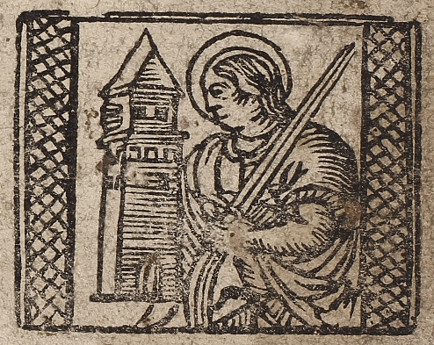

The conference is organized under the umbrella of the framework NAKI II Broadside Ballads in the Historical Collections in Brno (DG18P02OVV021) and it is intended for all specialists for whom Broadside Ballads are a relevant source – be it librarians, literary scientists, linguists, musicologists, ethnologists and cultural anthropologists, historians, art historians and museum workers.
The conference organizers especially welcome interdisciplinary contributions and contributions concerning methodology used for this type of research. The following topics are highly welcome:

- Possible definitions of the Broadside Ballads genre and/or Broadside Print production;
- Broadside Ballads as subject of Bibliography Science (production, printing houses, distribution, censorship);
- The language aspect of Broadside Ballads;
- Adaptation of foreign texts / themes;
- Intertextuality and Intermediality in Broadside Ballads;
- Reception and collectibles of Broadside Ballads;
- Readers and listeners of Broadside Ballads;
- Broadside Ballads melodies;
- Publishers‘ self-presentation (e.g., printing houses, monastic orders, pilgrim places, etc.);
- Broadside Ballad as a medium of memory;
- Broadside Ballads media (print, handwriting, oral tradition);
- Historical events reflected in Broadside Ballads;
- Stylistic and thematic stereotypes in Broadside Ballads;
- Broadside Ballads as a manifestation of popular culture;
- Broadside Ballads‘ place in the system of contemporary genres;
- Political and religious propaganda in Broadside Ballads;
- Ethnological and hymnological aspects of Broadside Ballads;
- Visual aspects of Broadside Ballads;
- Czech Broadside Ballads in the European context.

The conference is possible due to support of the Ethnological Institute of the Academy of Sciences of the Czech Republic, v. v. i.; The Moravian Library and the Moravian Museum (as a part of the project NAKI Broadside Ballads in the Historical Collections in Brno - DG18P02OVV021).

Contributions are selected after a peer review process (two external assessments). The Organizing Committee reserves the right to select the contributions that will be presented.

This announcement has rather an informative character – the call for papers with a binding application will be sent out in the first quarter of the year 2019.

A conference fee of CZK 1000 is expected.

We do not plan conference proceedings; however, there is the possibility to include selected contributions to an English-written collective monograph, or, alternatively, to send it to Folia ethnographica, Český lid, Linguistica Brunensia or Literraria Bohemica.

Organizers are grateful for any ideas or queries about the conference.

The Organizers

doc. Mgr. Pavel Kosek, PhD.
prof. PhDr. Jana Pleskalová, CSc. | prof. PhDr. Michaela Soleiman pour Hashemi, CSc.
Mgr. Veronika Bromová, PhD. | doc. PhDr. Hana Bočková, Dr.
Mgr. Olga Navrátilová, PhD. | Mgr. Marie Hanzelková, PhD.

If you have any questions concerning the conference, please contact us at kramarskepisne2019@seznam.cz

Department of Czech Language, Faculty of Arts, Masaryk University
A. Nováka 1
602 00 Brno
Czech Republic

